CHAPTER 32
ELECTROMAGNETIC WAVES
Discussion Questions
Q32.1 Yes. The direction of the vector product 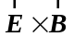 can be determined and the wave is traveling in this direction so must have come from the opposite direction.

Q32.2 The steel girders are conductors and absorb radio waves and prevent the waves from getting to the car.

Q32.3 Visible light from a light bulb, microwaves in a microwave oven, and radio waves received by a radio are all electromagnetic waves. These waves all consist of oscillating electric and magnetic fields and travel in air with the same speed . These different kinds of electromagnetic waves have different frequencies and therefore different wavelengths.

Q32.4 The electric fields of the intense radio waves produce currents in the signs.

Q32.5 Only transverse waves can be polarized. All electromagnetic waves can be polarized but sound waves cannot.

Q32.6 Once the wavefront reaches the charge the uniform, constant electric field in the wave will exert a constant force on the charge in the direction of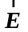, and this gives the charge a constant acceleration.

Q32.7 The intensity of such a wave would be 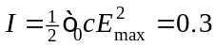 W/cm. This is too little energy to induce any appreciable currents in the person’s body. Also, the frequency of the visible light waves is about 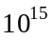 Hz and it is difficult to produce such very high frequency currents in a person’s body.

Q32.8 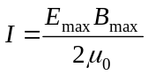. 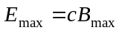 so 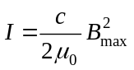. For I to double, the magnetic field amplitude 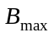is increased by a factor of 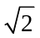.

Q32.9 No, the frequency of oscillation of the magnetic field of the light is about 10 Hz and due to the mass of the compass needle it would take a very large current to cause it to oscillate at this extremely high frequency. The earth’s field is much weaker but is constant in time.

Q32.10 The electric field of the radio waves must be polarized in the vertical direction.

Q32.11 Yes, the same momentum conservation principle applies and there is a recoil effect. But the momentum carried by the light is very small so the recoil force is also very small and is not detectable.

Q32.12 For a perfectly reflecting surface 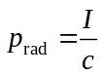. Eq.(15.26) applies to electromagnetic waves: 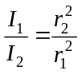. 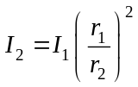. If the distance is doubled then the intensity is multiplies by and the radiation pressure 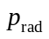 is multiplied by . Therefore, the radiation pressure would be 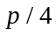.

Q32.13 The standing wave has energy in its electric and magnetic fields but does not transport energy through space like a traveling wave does. Similarly, the electric and magnetic fields in the standing wave have momentum but there is no momentum flow like there is for a traveling wave. As shown in Example 32.6 the intensity or time average of at any point in a standing wave is zero.

